Year 9 Food Journeys
Design Challenge: You (and your team) are to design a 10 day food journey itinerary for a 2017 travel destination and that covers the planning of all components of the trip including; travel details (air, sea and land), accommodation, activities, locations and restaurants/taverns/hotels/street food.
This major assessment task has three parts
Part 1: This part covers the research to provide you with background information and knowledge about your travel and accommodation to ensure that your trip is both financially, culturally and environmentally sustainable.
Part 2: This part covers the research to provide you with background information and knowledge about the culinary (food safety/preservation, food customs and nutritional etc.) components of your trip.
Part 3: This part involves the design process from the planning (investigation), preparation and cooking (generating and producing), project managing (planning and managing) and evaluating (evaluating) the success of your trip.

Part 1: Victorian Curriculum Content 1 and 2: Food and Society
- Critically analyse factors, including social, ethical and sustainability considerations, that impact on designed solutions for global preferred futures and the complex design and production processes involved
- Explain how designed solutions evolve with consideration of preferred futures and the impact of emerging technologies on design decisions

Planning: Imagine you are hosting a culinary tour for 10 friends that costs $2,500 to $3,000 in total. The tour must be eco-tourist friendly (see Eco-tourism Australia for definition and examples of sustainability) and show evidence that your itinerary accommodates environmental and cultural sustainability.
- Use a mind map (see eg for Australiamindmap) to help you brainstorm all the components that you need to consider (climate, seasonal variations, eco-friendly, budget considerations, travel safety and insurance, vaccinations, packing)
(Hint: post ‘culinary tours’ into your search engine)
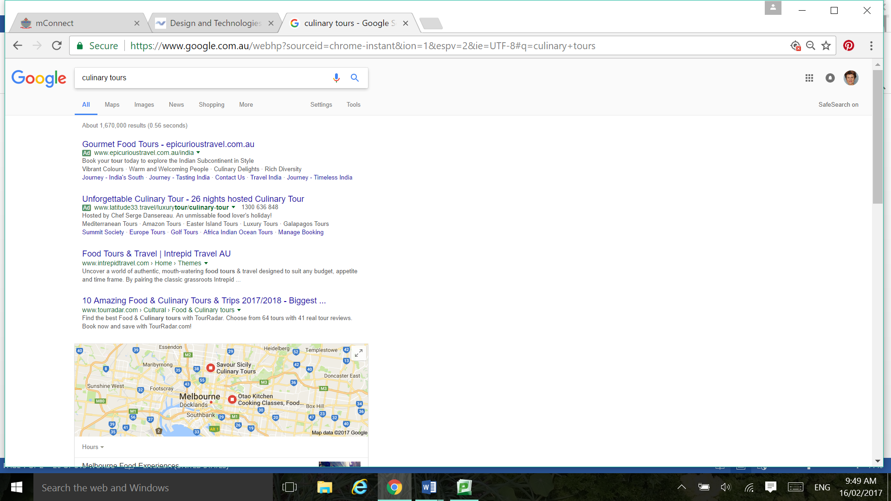
- Explain how your itinerary meets the objectives of a culinary food tour of your travel destination AND is sustainable for each aspect: cultural and environmental. You need to show how you have selected your preferred option from at least three alternatives (For eg, why you have selected a glamping tour next to the beach OR staying a 5 star inland resort with 3 pools OR a locally run Air BnB run by ex-pats ) evolve with consideration of preferred futures and the impact of emerging technologies on design decisions
- Budget: you need to provide a costing (in $AUS) for each of the items: travel (air and land), insurance, accommodation, food, spending money, gratuities. You may need to calculate a currency conversion from destination currency to Australian dollars.
Resources
Ecological footprint calculator : look at this web site to find out your carbon footprint and how to minimise your food waste, carbon footprint when travelling. From the http://www.wwf.org.au/ (accessed February 17, 2017)
http://www.traveller.com.au/leave-no-carbon-footprints-85qp (eco-friendly holidays here and overseas) (accessed February 17, 2017)
Smart Traveller –Department of Foreign Affairs (accessed February 17, 2017)

Part 2: Victorian Curriculum Context 1 and 2
Investigate and make judgements on how the principles of food safety, preservation, preparation, presentation and sensory perceptions influence the creation of food solutions for healthy eating
Investigate and make judgements on how the characteristics and properties of food, components, tools and equipment can be combined to create designed food solutions
Part 2 covers the food decisions that you will need to make when catering for your group of ten people (including yourself).
- Brainstorm the food sources available to you at your travel destination: restaurants, hotels, self-catered sourced from local vendors and markets, street food/warungs (for example; https://www.bali.com/warung-streetfood.html )
- Use a new mind map to consider food safety (risks/prevention), food preparation and storage and nutritional value. You may need to research background information about the food and how it is sourced at your destination country.
- Research the typical ingredients of your destination country (see The Food Book, p.12 -27 for general information and as a starting point). To demonstrate your understanding of food systems (‘Paddock to Plate’), choose two typical ingredients (for example, rice and corn) and show how it is grown (plants), raised (animals). See Heath et al reference below and attached to your files on mConnect.

Resources
Compton, L et al 2010 The Food Book, Oxford University Press, South Melbourne pp, 10-27 (Food origins), p. 40 (Food miles), pp. 462-onwards (Food skills)
Fuse Education: type in your request to access videos and text resources (recommended for Part 2)
Reduce your footprint: food systems and paddock to plate (recommended for Part 2)
Heath G, Mc Kenzie H, Tully L 2016 Food Solutions Nelson South Melbourne pp. 146-150
Compton, L et al 2010 The Food Book, Oxford University Press, South Melbourne pp, 10-27 (Food origins), p. 40 (Food miles), pp. 462-onwards (Food skills)

Part 3: Victorian Curriculum Creating Designed Solutions
Investigating: Critique needs or opportunities to develop design briefs and investigate and select an increasingly sophisticated range of materials, systems, components, tools and equipment to develop design ideas
Generating: Apply design thinking, creativity, innovation and enterprise skills to develop, modify and communicate design ideas of increasing sophistication
Producing: Work flexibly to safely test, select, justify and use appropriate technologies and processes to make designed solutions
Evaluating: Evaluate design ideas, processes and solutions against comprehensive criteria for success recognising the need for sustainability
Planning and managing: Develop project plans to plan and manage projects individually and collaboratively taking into consideration time, cost, risk and production processes.

The Design Process
